City Administrator Report

May 19th, 2020

Dear Mayor and Members of the City Council:

The months continue to speed by as staff and I have been staying increasingly busy. Busy is good, as it shows that there are positive things going on in Valley Falls!

Discussing the 2020 Swimming Pool season will be a key item at the May 27th meeting.

I have polled surrounding (more similar in size than Topeka) communities with swimming pools. Here are the results:

Atchison: Not opening.
Effingham: Not opening.
Holton: Not opening.
Oskaloosa: Wanting to open.
Wamego: More information presented at the May 27th City Council meeting.
Tonganoxie: Not opening.

Staff will be prepared for the conversation on May 27th about opening the pool for the 2020 season. If you have any specific information which would help you make a decision, please let me know and I will prepare it.

I had a good time going to Lowes/Menards with newly hired Public Works team member Bill McCoy and getting materials for the Council-approved 5th and Walnut intersection project. At the time of this writing, the Public Works department has started clearing the intersection, with Approved paving slated to come in afterward and complete the job. We anticipate the intersection being closed for two weeks. We will advise you and the public if there is a delay.
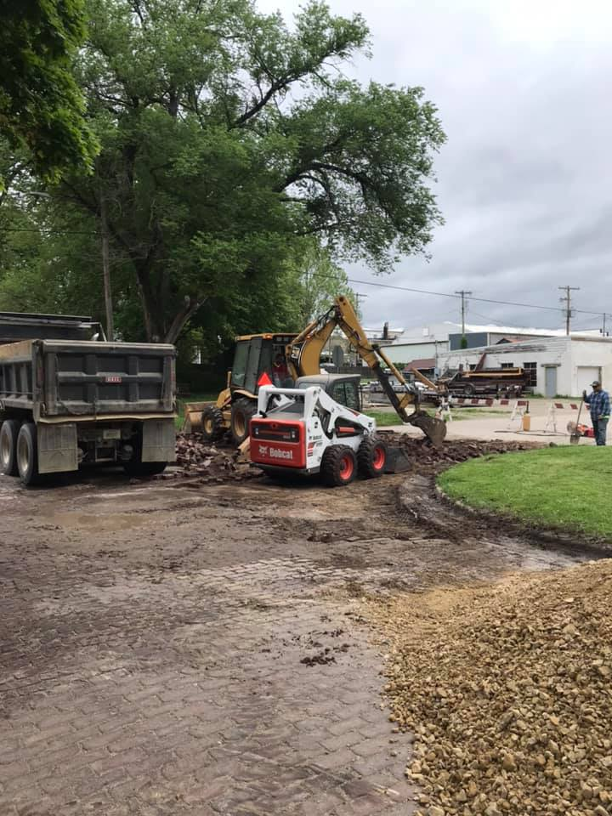
Other information…

Municipal Court has been postponed until May 27. Understandably, this has put a lot of cases on hold. We will begin new Health and Welfare Code Enforcement inspections the end of May.

I will be reaching out to each of you sometime in the next month to schedule City Council tours of the Police Department, and Swimming pool facility. This will be completed prior to approving a budget for FY2021. More information to come.

City Hall is allowing one (1) person at a time entry to City Hall. In addition to cleaning, we have installed this shield:
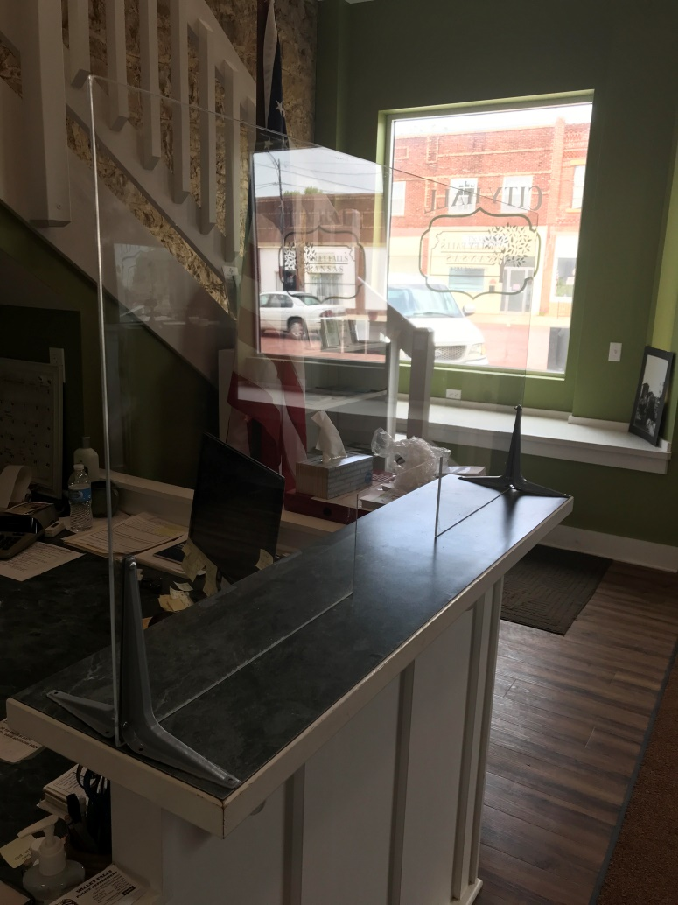

Last week I participated in a virtual budget workshop conducted by the Kansas Department of Administration. The Mayor and I will be spending a lot of my time over the next week preparing a draft of FY2021.

As a result of the last council meeting:

Staff has completed an ordinance which would accomplish proposed changes to Council meetings.

The contract with Doyle Caldwell has been completed, and signed. They are happy buyers and we look forward to seeing their finished project.

KDOT Cost Share Program application has been submitted. Staff has been advised that a decision will be made sometime in late June.

We are happy to welcome Lucas Welborn and Diego Cervantez to the Public Works crew. They have been working hard this week, and we look forward to having them around this summer.

We are waiting on the Sewer contract for services from PEC – staff has already received the water contract. Once we receive both of these items, staff will analyze and prepare our thoughts for Council consideration.

Planning and Zoning Board:
There is a vacancy on the Planning and Zoning board.

Meetings recently attended included: Department Heads, meetings with Council Members, , City Attorney, Watson Development, and meeting regarding lots on Oak Street, Swimming Pool Manager and Assistant.

City Council Meetings, Study Sessions, and Executive Sessions
Tentative future City Council agendas include the following items at this time:

1. FEMA Disaster Recovery application.
2. Pool 2020 Season

Code Enforcement Statistics:
This section will include a report of the number of cases currently in the code enforcement process, as outlined in City Ordinance. This section will be the analysis provided to the council, unless there is a practical application of discussing properties and/or owner name(s). (I.E. on the agenda, citizen complaint or public comment, need to approve expenditure above $500, etc.) Please advise if you have any questions about this, and/or have suggestions.

Code Enforcement Phase | # of Cases
Violation Observed/ Letter Pending: | 0
30 Day Notice Letter Sent | 3
30 Day Letter Re-inspect / 10 Day Letter Pending | 0
10 Day Letter Sent | 0
10 Day Letter Re-inspect / Review w/ Admin Hearing Officer/ Sent to Municipal Attorney | 1
Cases pending court | 5
NEKES
Cases Pending | 1  0 new cases  2 cases has been resolved
Website update:
This section will be a brief update on the progress being made on the website. Please review, and let me know if you have some suggestions.

Upload agendas
Upload minutes
Upload CA report

Planned items on website update:
Economic profile
Economic Development Committee
Mayor and City Council
City Financial Health Snapshot:

Updated reports are prepared for the last meeting of each month.

I have done some digging to present trends since 2016. As you can see, our ‘ALL FUNDS’ balance has remained consistent since 2016, which is positive considering all of the major projects the City has undertaken recently.

The first four months of FY20 have been a mixed bag. In April, our General Fund experienced a lot of big ticket expenses, all at once (i.e. Insurance policy payment, etc.) which has been reflected in our ending balance.

Our revenues come in different amounts each month, based on when funds are dispersed. With that said, May will be a big month in determining how the rest of our FY goes. As we stand right now, I envision our revenue to come in comparable to years past. However, I fully anticipate that our first COVID-related reduction in revenue will be experienced this Fall.

This makes accurate planning nearly impossible as there are still a lot of unknown factors. I want to remain optimistic that revenues will not experience an organization-altering decline, but I cannot in good faith tell you that it will not. There are so many unknown factors still waiting to reveal themselves. The ‘dirty little secret’ is that there are not reliable estimates of how big of a decline in revenues there will be for localities - only guesses. Right now, the League of Kansas municipalities is advising us to plan for a 15% reduction in revenue. Only time will be able to show how accurate this is.

With so much uncertainty, my professional recommendation is to pull back spending and conserve as much as possible - especially in General Fund spending. Over the next four months, I am recommending a cautious approach to General Fund spending. In typical years, if we approach our spending authority, we can amend the budget to address any additional spending that is needed as long as our revenues are appropriate. This is not a typical year.

Over the next four months (May-August), I will be keeping a close eye on how revenues come in. If there is a steep decline, as some of our peers are predicting, we will need to reduce spending. I have prepared a contingency plan for August/September-December which can reduce spending to revenue-reflected levels, should the need arise.

Our Water and Sewer funds remain strong. This means that I am still comfortable moving forward with PEC on pursuing engineering plans which will put us in a position to pursue funding for major infrastructure improvements.

Please see the separate attachment:

Fund Balance:
I have been working on a four year history – obviously this is not complete yet .I will have the remaining information completed for the next meeting.

Month (End Balance) | General | Water | Sewer | Capital Improvement | Consolidated Streets and Highway | Special Equipment Reserve | Solid Waste | Bond and Interest | All Funds
January 2016 | $257,123.68 | $98,194.37 | $244,194.04 | $0.00 | $324,111.78 | $10,368.57 | $74,294.05 | $0.00 | $1,008,286.49
February 2016 | $247,491.45 | $108,236.93 | $250,378.88 | $0.00 | $324,111.78 | $10,368.57 | $68,760.64 | $0.00 | $1,009,348.25
March 2016 | $244,887.18 | $106,710.59 | $248,717.37 | $0.00 | $324,111.78 | $10,368.57 | $76,061.29 | $0.00 | $1,010,251.11
April 2016 | $213,162.28 | $103,275.45 | $245,715.27 | $0.00 | $331,399.97 | $10,368.57 | $76,333.24 | $0.00 | $980,254.78
May 2016 | $203,563.95 | $108,520.39 | $247,782.44 | $0.00 | $331,399.97 | $10,368.57 | $69,473.47 | $0.00 | $971,108.79
June 2016 | $256,253.47 | $115,709.43 | $250,495.61 | $0.00 | $331,399.97 | $10,368.57 | $77,143.29 | $0.00 | $1,041,370.34
July 2016 | $224,028.74 | $105,328.43 | $250,154.72 | $0.00 | $338,978.45 | $10,368.57 | $77,100.99 | $0.00 | $1,005,959.90
August 2016 | $202,781.34 | $107,960.44 | $230,224.65 | $0.00 | $338,978.45 | $10,368.57 | $77,690.44 | $0.00 | $967,627.14
September 2016 | $177,472.74 | $113,451.76 | $231,807.20 | $0.00 | $328,928.45 | $10,368.57 | $77,487.22 | $0.00 | $939,205.66
October 2016 | $309,718.81 | $122,355.25 | $236,787.48 | $1,296,404.75 | $337,160.54 | $10,368.57 | $78,407.25 | $0.00 | $2,391,140.50
November 2016 | $29,228.66 | $128,058.83 | $238,964.99 | $1,285,841.01 | $337,160.54 | $10,368.57 | $78,102.30 | $153,500.00 | $2,258,958.95
December 2016 | $114,622.52 | $134,361.61 | $245,995.53 | $1,447,725.46 | $332,135.54 | $10,368.57 | $79,187.77 | $153,720.70 | $2,518,117.70
January 2017 | $217,132.35 | $122,270.31 | $249,869.90 | $1,382,890.34 | $339,945.62 | $10,368.57 | $72,484.70 | $153,720.70 | $2,468,411.90
February 2017 | $199,342.69 | $129,417.24 | $254,261.90 | $1,382,890.34 | $339,945.62 | $10,368.57 | $79,971.06 | $153,720.70 | $2,549,855.77
March 2017 | $192,458.58 | $135,085.85 | $258,254.50 | $1,317,890.34 | $339,945.62 | $10,368.57 | $66,650.48 | $162,835.74 | $2,481,954.27
April 2017 | $167,406.22 | $124,009.66 |  |  |  |  |  |  | $2,457,760.37
May 2017
June 2017
July 2017
August 2017
September 2017
October 2017
November 2017
December 2017
January 2018 | $273,900.97 | $153,730.24 | $282,874.84 | $343,170.44 | $55,411.86 | $10,368.57 | $78,776.27 | $223,094.12 | $1,422,162.87
February 2018 | $259,249.42 | $154,759.27 | $287,409.57 | $267,703.71 | $54,529.15 | $10,368.57 | $80,113.90 | $233,146.45 | $1,348,139.96
March 2018 | $252,650.60 | $160,451.42 | $290,675.20 | $202,085.26 | $54,529.15 | $10,368.57 | $80,175.78 | $182,032.88 | $1,233,828.78
April 2018 | $232,010.23 | $156,381.74 | $259,221.27 | $125,185.34 | $61,618.93 | $10,368.57 | $80,196.22 | $191,966.72 | $1,117,808.94
May 2018 | $215,938.20 | $164,366.77 | $262,540.36 | $182,223.63 | -$39,393.57 | $10,368.57 | $81,107.74 | $200,797.80 | $1,078,809.42
June 2018 | $274,604.82 | $163,633.53 | $266,117.22 | -$3,659.19 | -$53,407.50 | $10,368.57 | $81,052.89 | $212,141.33 | $951,711.59
July 2018 | $234,576.18 | $155,854.86 | $270,387.77 | -$3,169.07 | -$46,906.36 | $10,368.57 | $80,961.83 | $217,184.60 | $920,118.30
August 2018 | $217,376.62 | $167,575.01 | $274,954.83 | -$3,099.86 | -$47,475.43 | $10,368.57 | $80,819.30 | $225,563.60 | $926,942.56
September 2018 | $240,121.14 | $178,896.50 | $280,660.43 | -$2,999.73 | -$52,296.71 | $10,368.57 | $81,426.35 | $212,203.57 | $949,240.04
October 2018 | $216,568.08 | $180,275.16 | $281,591.05 | -$2,903.21 | -$39,517.99 | $10,368.57 | $80,848.06 | $220,569.90 | $947,799.62
November 2018 | $185,786.81 | $185,282.77 | $285,282.62 | -$2,803.07 | -$30,719.81 | $10,368.57 | $80,818.06 | $229,368.08 | $943,384.03
December 2018 | $146,031.70 | $194,280.36 | $288,894.76 | $384.95 | $0.00 | $10,368.57 | $54,868.92 | $237,722.87 | $932,552.13
January 2019 | $239,546.67 | $185,520.12 | $294,604.34 | $739.32 | $14,667.78 | $11,318.57 | $55,360.50 | $252,390.66 | $1,054,147.96
February 2019 | $210,425.74 | $184,356.84 | $298,999.32 | $1,105.70 | $23,579.93 | $11,318.57 | $55,853.17 | $261,302.81 | $1,046,609.97
March 2019 | $207,425.82 | $188,663.94 | $304,756.82 | $1,436.68 | $34,379.96 | $11,318.57 | $55,669.44 | $185,564.08 | $989,215.31
April 2019 | $163,195.59 | $176,383.06 | $297,809.74 | $1,803.12 | $45,281.08 | $11,318.57 | $55,309.72 | $196,465.19 | $947,566.07
May 2019 | $142,047.35 | $181,021.67 | $298,901.97 | $2,157.73 | $55,231.83 | $11,318.57 | $55,245.45 | $205,415.94 | $951,340.51
June 2019 | $190,356.98 | $186,576.20 | $285,402.09 | $2,524.17 | $64,862.64 | $11,318.57 | $55,161.86 | $215,046.75 | $1,010,675.72
July 2019 | $167,418.05 | $186,384.18 | $267,856.25 | $2,878.82 | $73,832.41 | $11,318.57 | $55,732.99 | $224,016.52 | $999,099.64
August 2019 | -$49,678.65 | $361,006.98 | $258,660.85 | $3,245.29 | $84,093.67 | $11,318.57 | $55,315.56 | $234,277.79 | $958,240.06
September 2019 | -$83,175.29 | $366,284.31 | $264,246.57 | $3,611.84 | $96,452.78 | $11,318.57 | $55,300.82 | $225,488.15 | $939,527.75
October 2019 | -$95,554.55 | $364,463.48 | $268,677.55 | $3,966.53 | $96,452.78 | $11,318.57 | $56,326.93 | $235,979.81 | $929,669.28
November 2019 | -$116,018.27 | $370,162.78 | $273,664.10 | $4,333.04 | $96,452.78 | $11,318.57 | $55,612.04 | $246,726.61 | $942,251.65
December 2019 | $39,168.00 | $179,970.19 | $280,999.87 | $4,687.79 | $96,452.78 | $11,318.57 | $47,310.10 | $255,934.20 | $915,841.50
January 2020 | $154,827.72 | $174,465.81 | $273,155.74 | $5,054.34 | $96,452.78 | $5,656.13 | $55,471.61 | $267,254.26 | $1,032,338.39
February 2020 | $128,559.30 | $179,534.60 | $278,937.78 | $5,420.89 | $96,452.78 | $5,656.13 | $55,313.63 | $277,054.93 | $1,026,930.04
March 2020 | $117,603.06 | $180,542.04 | $282,612.01 | $5,763.84 | $96,452.78 | $5,656.13 | $55,570.38 | $201,724.02 | $945,924.26
April 2020 | $55,972.38 | $166,169.75 | $276,387.97 | $5,763.84 | $103,905.91 | $5,656.13 | $55,880.46 | $209,882.48 | $879,619.02
Average | $169,945.67 | $170,680.46 | $267,904.36 | $215,587.31 | $141,653.27 | $10,195.32 | $68,622.05 | $164,135.21 | $1,236,388.80

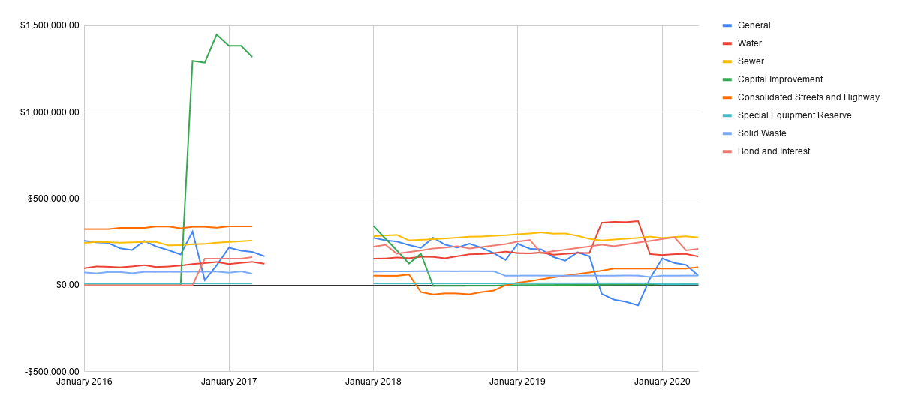

Published Budget Status:
Fund (April) | Current | Bugeted | Remaining | Percent Remaining
General | $235,685.59 | $656,342.00 | $420,656.41 | 64.09%
Consolidated Street and Hwy | $0.00 | $113,000.00 | $113,000.00 | 100%
Water | $81,807.56 | $255,205.00 | $173,397.44 | 67.94%
Sewer | $50,886.86 | $160,562.00 | $109,675.14 | 68.31%
Solid Waste | $24,292.54 | $99,273.00 | $74,980.46 | 75.53%
Total | $392,672.55 | 1,284,382 | $891,709.45 | 69.43%
Outstanding Indebtedness | Current | Budgeted | Remaining
G.O. Bonds | $86,148.75 | $1,535,000.00
Other | $0.00 | $47,240.00
Total | $86,148.75 | $1,582,240.00

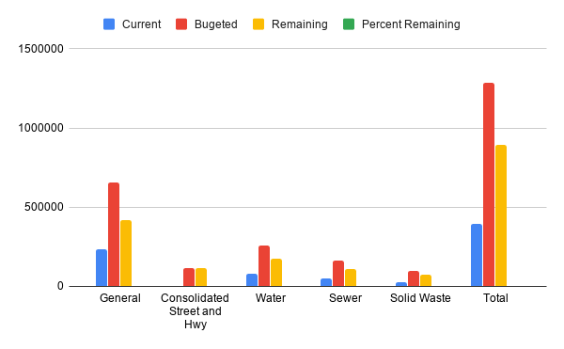
Published Budget w/ Cuts (-15%):
Fund (April) | Current | Bugeted | Remaining | Percent Remaining
General | $235,685.59 | $557,890.70 | $322,205.11 | 57.75%
Consolidated Street and Hwy | $0.00 | $96,050.00 | $96,050.00 | 100%
Water | $81,807.56 | $191,424.25 | $109,616.69 | 57.26%
Sewer | $50,886.86 | $136,477.70 | $85,590.84 | 62.71%
Solid Waste | $24,292.54 | $99,273.00 | $74,980.46 | 75.53%
Total | $392,672.55 | 1,081,116 | $688,443.10 | 63.68%
Outstanding Indebtedness | Current | Budgeted | Remaining
G.O. Bonds | $86,148.75 | $1,535,000.00
Other | $0.00 | $47,240.00
Total | $86,148.75 | 1,582,240

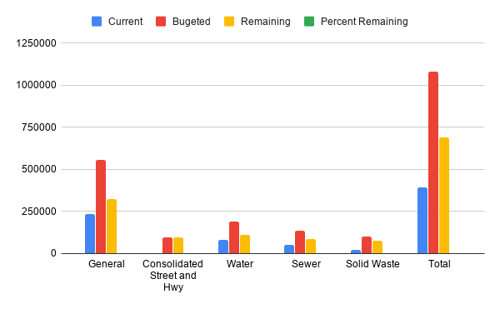
Income/Expenses (All funds):

Fund | 1/2020 | 2/2020 | 3/2020 | 4/2020 | 5/2020 | 6/2020 | 7/2020 | 8/2020 | 9/2020 | 10/2020 | 11/2020 | 12/2020 | Total
General
Income | $179,822.75 | $22,686.49 | $30,830.98 | $19,149.75 |  |  |  |  |  |  |  |  | $252,489.97
Expenses | $64,017.97 | $48,922.41 | $41,787.22 | $80,780.33 |  |  |  |  |  |  |  |  | $235,507.93
Result | $115,804.78 | -$26,235.92 | -$10,956.24 | -$61,630.58 |  |  |  |  |  |  |  |  | $16,982.04
Consolidated Street and Hwy
Income | 0 | 0 | 0 | 0 |  |  |  |  |  |  |  |  | 0
Expenses | 0 | 0 | 0 | 0 |  |  |  |  |  |  |  |  | 0
Result | 0 | 0 | 0 | 0 |  |  |  |  |  |  |  |  | 0
Water
Income | 16,664.85 | 18,124.98 | 16,310.51 | 16906.78 |  |  |  |  |  |  |  |  | 68,007.12
Expenses | 22,169.23 | 13,056.19 | 15,303.07 | 31,279.07 |  |  |  |  |  |  |  |  | 81,807.56
Result | -5,504.38 | 5,068.79 | 1,007.44 | -14,372.29 |  |  |  |  |  |  |  |  | -13,800.44
Sewer
Income | 10,760.16 | 12,404.09 | 11,157.13 | 11953.58 |  |  |  |  |  |  |  |  | 46,274.96
Expenses | 18,604.29 | 6,622.05 | 7,482.90 | 18177.62 |  |  |  |  |  |  |  |  | 50,886.86
Result | -7,844.13 | 5,782.04 | 3,674.23 | -6224.04 |  |  |  |  |  |  |  |  | -4,611.90
Solid Waste
Income | 8,161.51 | 7,762.36 | 8,297.09 | 8641.94 |  |  |  |  |  |  |  |  | 32,862.90
Expenses | 0.00 | 7,920.34 | 8,040.34 | 8331.86 |  |  |  |  |  |  |  |  | 24,292.54
Result | 8,161.51 | -157.98 | 256.75 | 310.08 |  |  |  |  |  |  |  |  | 8,570.36
Outstanding indebtedness
G.O. Bonds
Income | 11,320.06 | 9,800.67 | 10,817.84 | 8158.46 |  |  |  |  |  |  |  |  | 40,097.03
Expenses | 0 | 0 | 86,148.75 | 0 |  |  |  |  |  |  |  |  | 86148.75
Result | 11,320.06 | 9,800.67 | -75,330.91 | 8158.46 |  |  |  |  |  |  |  |  | -46,051.72

