Monthly City Administrator Report

June 16th, 2020

Dear Mayor and Members of the City Council:

Staff continues to stay busy this summer. Lots of movement, both government and private, lends to the belief that Valley Falls has a real opportunity to grow.

The intersection project at 5th and Walnut nears completion. Approved Paving has poured the curbs and gutters, with the rest of the intersection set to be poured later this week. Hopefully early next week staff will be able to open the intersection.

Jefferson County has demolished the Freeborn property. We anticipate that this newly cleared lot will be highly attractive to potential buyers. If you know an interested buyer, please direct them to Jefferson County Clerk.

The Barnes Addition is growing right before our eyes. At this moment, we have three house with serious improvements completed in Barnes Subdivision No. 3. We have with significant progress in Barnes Addition No. 2. Hopefully in the next few months, we will have progress made on eight additional houses in Barnes Subdivision No. 3, and one additional house in Barnes Subdivision No. 2. With all thirteen of these single family houses in mind, the City is looking at over 2 million in additional assessed valuation.

As a result of the City Council decision to open the swimming pool for the 2020 season, staff has been busy making preparations for opening. At this time, staff appears to be on schedule to open as previously thought. If there is a delay, we will let you know.

I have been very busy making preparations for the FY 2021 budget. At this time, I am requesting that the Council approach next year in a very reserved fashion until we have more months of data to determine the economic consequences of the stay at home orders. At this point, I have prepared a draft budget which is reflective of mirroring the 2020 budget. Essentially, keeping the proportions of staffing, equipment purchases, and special projects the same as 2020.

When we get later in the 2020 fiscal year, we will be better able to determine how big of projects the City can undertake in 2021. The week of June 22nd-June 26th, the Mayor and I will be working on finalizing a budget to be ready for a budget hearing in August.

Moreover, if the City Council decides to move ahead with Sewer/Water engineering work, this will require a budget amendment for FY2020, in both funds. Alex Darby has provided contracts for water and sewer work for staff review – this will be an agenda item for July 15th. I have sent a copy to the City Council for consideration until that meeting.

Rick Penner, of Viking Industrial Painting, has been to the water tower to evaluate the changes that need to be made. He advised that his crew is in Illinois working at the moment, but that repainting the tower will begin in the near future.

Brett Waggoner, of Governmental Assistance Services, has advised that the survey is 15% complete. He intends to have at least 50% of the survey completed by June 22nd. With good weather cooperation, of course. A letter was sent to all Valley Falls residents outlining why GAS is conducting this survey, and why it is important. Please spread the word that this can help us access large sums of funding to help with critical infrastructure projects.

I received a request from the Valley Falls Recreation Commission on June 16th:

“Joe and Valley Falls City Council,

The VF Recreation Commission is in need of someone to brush hog the sides of the walking trail. We have someone that mows it but due to the brush that was cut earlier this spring there are quite a few stumps that a mower cannot handle. We were wondering if the city would provide this service for us, at least until we can get something else figured out. It is our plan to start re-working the trail to make it useable and more appealing.

If you have any questions please let me know.

Thank you for your consideration of this request.

Jeri Clark”

This will be an impromptu agenda item for the City Council meeting.
Other information…

Municipal Court resumed on May 27^{th.} All went well during court, as only each individual case was allowed in the building at a time to allow for social distancing. Court will be held again on June 24th.

As a result of the last council meeting:

Staff has completed an ordinance which would accomplish proposed changes to Council meetings.

Planning and Zoning Board:
There is a vacancy on the Planning and Zoning board.

Watson Development will be submitting the building permits for the recently purchased lots sometime in the coming weeks. Once submitted, I will work to get the permits approved. As long as there is not a need for variances or conditional uses, this should only take a week to turnaround.

Meetings recently attended included: Department Heads, meetings with Council Members, City Attorney, Watson Development, title company.

City Council Meetings, Study Sessions, and Executive Sessions
Tentative future City Council agendas include the following items at this time:

1. FEMA Disaster Recovery application.
2. Budget conversation – send to budget hearing phase.

Code Enforcement Statistics:
This section will include a report of the number of cases currently in the code enforcement process, as outlined in City Ordinance. This section will be the analysis provided to the council, unless there is a practical application of discussing properties and/or owner name(s). (I.E. on the agenda, citizen complaint or public comment, need to approve expenditure above $500, etc.) Please advise if you have any questions about this, and/or have suggestions.

Code Enforcement Phase | # of Cases
Violation Observed/ Letter Pending: | 0
30 Day Notice Letter Sent | 10
30 Day Letter Re-inspect / 10 Day Letter Pending | 0
10 Day Letter Sent | 0
10 Day Letter Re-inspect / Review w/ Admin Hearing Officer/ Sent to Municipal Attorney | 0
Cases pending court | 4
Tall Grass/Weeds Cases pending abatement | 4
NEKES
Cases Pending | 1  0 new cases  0 cases have been resolved
Website update:
This section will be a brief update on the progress being made on the website. Please review, and let me know if you have some suggestions.

Upload agendas
Upload minutes
Upload CA report
Upload CCR

Planned items on website update:

City Financial Health Snapshot:

Updated reports are prepared for the last meeting of each month.

Please see the separate attachment:

Fund Balance:

.
Month (End Balance) | General | Water | Sewer | Capital Improvement | Consolidated Streets and Highway | Special Equipment Reserve | Solid Waste | Bond and Interest | All Funds
January 2016 | $257,123.68 | $98,194.37 | $244,194.04 | $0.00 | $324,111.78 | $10,368.57 | $74,294.05 | $0.00 | $1,008,286.49
February 2016 | $247,491.45 | $108,236.93 | $250,378.88 | $0.00 | $324,111.78 | $10,368.57 | $68,760.64 | $0.00 | $1,009,348.25
March 2016 | $244,887.18 | $106,710.59 | $248,717.37 | $0.00 | $324,111.78 | $10,368.57 | $76,061.29 | $0.00 | $1,010,251.11
April 2016 | $213,162.28 | $103,275.45 | $245,715.27 | $0.00 | $331,399.97 | $10,368.57 | $76,333.24 | $0.00 | $980,254.78
May 2016 | $203,563.95 | $108,520.39 | $247,782.44 | $0.00 | $331,399.97 | $10,368.57 | $69,473.47 | $0.00 | $971,108.79
June 2016 | $256,253.47 | $115,709.43 | $250,495.61 | $0.00 | $331,399.97 | $10,368.57 | $77,143.29 | $0.00 | $1,041,370.34
July 2016 | $224,028.74 | $105,328.43 | $250,154.72 | $0.00 | $338,978.45 | $10,368.57 | $77,100.99 | $0.00 | $1,005,959.90
August 2016 | $202,781.34 | $107,960.44 | $230,224.65 | $0.00 | $338,978.45 | $10,368.57 | $77,690.44 | $0.00 | $967,627.14
September 2016 | $177,472.74 | $113,451.76 | $231,807.20 | $0.00 | $328,928.45 | $10,368.57 | $77,487.22 | $0.00 | $939,205.66
October 2016 | $309,718.81 | $122,355.25 | $236,787.48 | $1,296,404.75 | $337,160.54 | $10,368.57 | $78,407.25 | $0.00 | $2,391,140.50
November 2016 | $29,228.66 | $128,058.83 | $238,964.99 | $1,285,841.01 | $337,160.54 | $10,368.57 | $78,102.30 | $153,500.00 | $2,258,958.95
December 2016 | $114,622.52 | $134,361.61 | $245,995.53 | $1,447,725.46 | $332,135.54 | $10,368.57 | $79,187.77 | $153,720.70 | $2,518,117.70
January 2017 | $217,132.35 | $122,270.31 | $249,869.90 | $1,382,890.34 | $339,945.62 | $10,368.57 | $72,484.70 | $153,720.70 | $2,468,411.90
February 2017 | $199,342.69 | $129,417.24 | $254,261.90 | $1,382,890.34 | $339,945.62 | $10,368.57 | $79,971.06 | $153,720.70 | $2,549,855.77
March 2017 | $192,458.58 | $135,085.85 | $258,254.50 | $1,317,890.34 | $339,945.62 | $10,368.57 | $66,650.48 | $162,835.74 | $2,481,954.27
April 2017 | $167,406.22 | $124,009.66 | $253,507.98 | $1,318,578.80 | $347,139.30 | $10,368.57 | $66,752.26 | $169,997.58 | $2,457,760.37
May 2017 | $157,481.95 | $131,040.45 | $255,342.14 | $1,301,352.66 | $345,327.30 | $10,368.57 | $66,955.26 | $179,788.08 | $2,447,656.41
June 2017 | $216,336.61 | $137,216.84 | $260,204.42 | $1,284,946.09 | $343,652.30 | $10,368.57 | $67,015.31 | $191,602.06 | $2,511,343.20
July 2017 | $195,128.63 | $129,202.21 | $264,452.11 | $1,222,925.67 | $347,532.99 | $10,368.57 | $66,706.15 | $202,593.20 | $2,438,909.53
August 2017 | $176,522.43 | $140,076.45 | $264,246.46 | $1,159,722.13 | $327,308.14 | $10,368.57 | $66,854.96 | $211,212.31 | $2,356,311.45
September 2017 | $203,368.99 | $143,469.72 | $268,370.08 | $1,031,655.30 | $324,214.34 | $10,368.57 | $66,385.52 | $180,731.65 | $2,228,564.17
October 2017 | $190,526.58 | $147,426.46 | $271,246.56 | $940,959.26 | $202,520.25 | $10,368.57 | $66,318.49 | $191,394.27 | $2,020,760.44
November 2017 | $181,730.58 | $155,818.06 | $273,946.88 | $799,366.66 | $94,707.50 | $10,368.57 | $66,212.43 | $201,966.40 | $1,784,117.08
December 2017 | $200,678.06 | $162,982.58 | $278,996.10 | $627,828.36 | $98,170.09 | $10,368.57 | $80,402.97 | $213,070.20 | $1,672,496.93
January 2018 | $273,900.97 | $153,730.24 | $282,874.84 | $343,170.44 | $55,411.86 | $10,368.57 | $78,776.27 | $223,094.12 | $1,422,162.87
February 2018 | $259,249.42 | $154,759.27 | $287,409.57 | $267,703.71 | $54,529.15 | $10,368.57 | $80,113.90 | $233,146.45 | $1,348,139.96
March 2018 | $252,650.60 | $160,451.42 | $290,675.20 | $202,085.26 | $54,529.15 | $10,368.57 | $80,175.78 | $182,032.88 | $1,233,828.78
April 2018 | $232,010.23 | $156,381.74 | $259,221.27 | $125,185.34 | $61,618.93 | $10,368.57 | $80,196.22 | $191,966.72 | $1,117,808.94
May 2018 | $215,938.20 | $164,366.77 | $262,540.36 | $182,223.63 | -$39,393.57 | $10,368.57 | $81,107.74 | $200,797.80 | $1,078,809.42
June 2018 | $274,604.82 | $163,633.53 | $266,117.22 | -$3,659.19 | -$53,407.50 | $10,368.57 | $81,052.89 | $212,141.33 | $951,711.59
July 2018 | $234,576.18 | $155,854.86 | $270,387.77 | -$3,169.07 | -$46,906.36 | $10,368.57 | $80,961.83 | $217,184.60 | $920,118.30
August 2018 | $217,376.62 | $167,575.01 | $274,954.83 | -$3,099.86 | -$47,475.43 | $10,368.57 | $80,819.30 | $225,563.60 | $926,942.56
September 2018 | $240,121.14 | $178,896.50 | $280,660.43 | -$2,999.73 | -$52,296.71 | $10,368.57 | $81,426.35 | $212,203.57 | $949,240.04
October 2018 | $216,568.08 | $180,275.16 | $281,591.05 | -$2,903.21 | -$39,517.99 | $10,368.57 | $80,848.06 | $220,569.90 | $947,799.62
November 2018 | $185,786.81 | $185,282.77 | $285,282.62 | -$2,803.07 | -$30,719.81 | $10,368.57 | $80,818.06 | $229,368.08 | $943,384.03
December 2018 | $146,031.70 | $194,280.36 | $288,894.76 | $384.95 | $0.00 | $10,368.57 | $54,868.92 | $237,722.87 | $932,552.13
January 2019 | $239,546.67 | $185,520.12 | $294,604.34 | $739.32 | $14,667.78 | $11,318.57 | $55,360.50 | $252,390.66 | $1,054,147.96
February 2019 | $210,425.74 | $184,356.84 | $298,999.32 | $1,105.70 | $23,579.93 | $11,318.57 | $55,853.17 | $261,302.81 | $1,046,609.97
March 2019 | $207,425.82 | $188,663.94 | $304,756.82 | $1,436.68 | $34,379.96 | $11,318.57 | $55,669.44 | $185,564.08 | $989,215.31
April 2019 | $163,195.59 | $176,383.06 | $297,809.74 | $1,803.12 | $45,281.08 | $11,318.57 | $55,309.72 | $196,465.19 | $947,566.07
May 2019 | $142,047.35 | $181,021.67 | $298,901.97 | $2,157.73 | $55,231.83 | $11,318.57 | $55,245.45 | $205,415.94 | $951,340.51
June 2019 | $190,356.98 | $186,576.20 | $285,402.09 | $2,524.17 | $64,862.64 | $11,318.57 | $55,161.86 | $215,046.75 | $1,010,675.72
July 2019 | $167,418.05 | $186,384.18 | $267,856.25 | $2,878.82 | $73,832.41 | $11,318.57 | $55,732.99 | $224,016.52 | $999,099.64
August 2019 | -$49,678.65 | $361,006.98 | $258,660.85 | $3,245.29 | $84,093.67 | $11,318.57 | $55,315.56 | $234,277.79 | $958,240.06
September 2019 | -$83,175.29 | $366,284.31 | $264,246.57 | $3,611.84 | $96,452.78 | $11,318.57 | $55,300.82 | $225,488.15 | $939,527.75
October 2019 | -$95,554.55 | $364,463.48 | $268,677.55 | $3,966.53 | $96,452.78 | $11,318.57 | $56,326.93 | $235,979.81 | $929,669.28
November 2019 | -$116,018.27 | $370,162.78 | $273,664.10 | $4,333.04 | $96,452.78 | $11,318.57 | $55,612.04 | $246,726.61 | $942,251.65
December 2019 | $39,168.00 | $179,970.19 | $280,999.87 | $4,687.79 | $96,452.78 | $11,318.57 | $47,310.10 | $255,934.20 | $915,841.50
January 2020 | $154,827.72 | $174,465.81 | $273,155.74 | $5,054.34 | $96,452.78 | $5,656.13 | $55,471.61 | $267,254.26 | $1,032,338.39
February 2020 | $128,559.30 | $179,534.60 | $278,937.78 | $5,420.89 | $96,452.78 | $5,656.13 | $55,313.63 | $277,054.93 | $1,026,930.04
March 2020 | $117,603.06 | $180,542.04 | $282,612.01 | $5,763.84 | $96,452.78 | $5,656.13 | $55,570.38 | $201,724.02 | $945,924.26
April 2020 | $55,972.38 | $166,169.75 | $276,387.97 | $5,763.84 | $103,905.91 | $5,656.13 | $55,880.46 | $209,882.48 | $879,619.02
May 2020 | $49,401.67 | $168,166.57 | $283,568.44 | $6,485.21 | $103,905.91 | $5,656.13 | $54,753.47 | $225,024.40 | $896,961.80
53 Month Average | $170,731.79 | $166,515.84 | $267,806.95 | $357,812.73 | $162,746.58 | $10,139.09 | $68,285.00 | $170,286.68 | $1,372,796.76
12-Month Average | $46,573.37 | $240,310.57 | $274,514.10 | $4,477.97 | $92,147.50 | $8,959.22 | $54,812.49 | $234,867.49 | $956,423.26
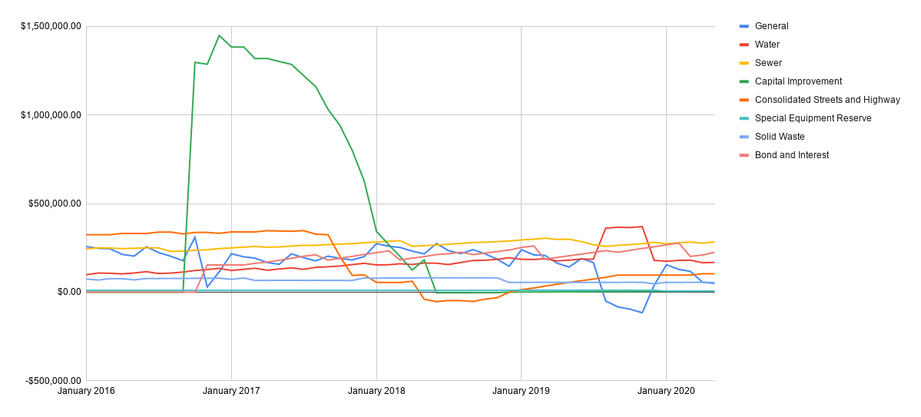

Published Budget Status:
Fund (May) | Current | Bugeted | Remaining | Percent Remaining
General | $283,746.96 | $656,342.00 | $372,595.04 | 56.77%
Consolidated Street and Hwy | $0.00 | $113,000.00 | $113,000.00 | 100%
Water | $98,936.99 | $255,205.00 | $156,268.01 | 61.23%
Sewer | $55,349.98 | $160,562.00 | $105,212.02 | 65.53%
Solid Waste | $33,642.73 | $99,273.00 | $65,630.27 | 66.11%
Total | $471,676.66 | 1,284,382 | $812,705.34 | 63.28%
Outstanding Indebtedness | Current | Budgeted | Remaining
G.O. Bonds | $87,148.75 | $1,535,000.00
Other | $0.00 | $47,240.00
Total | $87,148.75 | $1,582,240.00

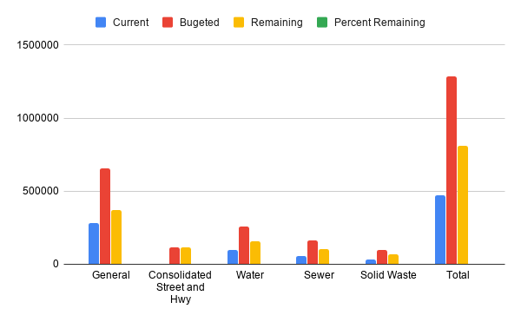

Published Budget w/ Cuts (-15%):
Fund (May) | Current | Bugeted | Remaining | Percent Remaining
General | $283,746.96 | $557,890.70 | $274,143.74 | 49.14%
Consolidated Street and Hwy | $0.00 | $96,050.00 | $96,050.00 | 100%
Water | $98,936.99 | $191,424.25 | $92,487.26 | 48.32%
Sewer | $55,349.98 | $136,477.70 | $81,127.72 | 59.44%
Solid Waste | $33,642.73 | $99,273.00 | $65,630.27 | 66.11%
Total | $471,676.66 | 1,081,116 | $609,438.99 | 56.37%
Outstanding Indebtedness | Current | Budgeted | Remaining
G.O. Bonds | $87,148.75 | $1,535,000.00
Other | $0.00 | $47,240.00
Total | $87,148.75 | 1,582,240

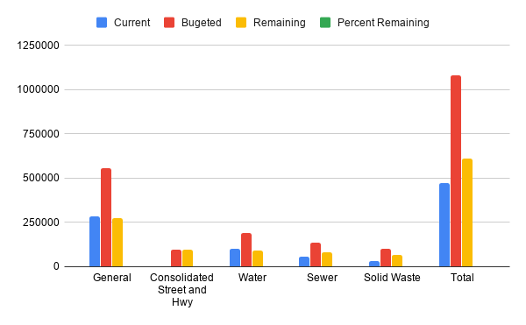

Income/Expenses (All funds):

Fund | 1/2020 | 2/2020 | 3/2020 | 4/2020 | 5/2020 | 6/2020 | 7/2020 | 8/2020 | 9/2020 | 10/2020 | 11/2020 | 12/2020 | Total
General
Income | $179,822.75 | $22,686.49 | $30,830.98 | $19,149.75 | $41,437.20 |  |  |  |  |  |  |  | $293,927.17
Expenses | $64,017.97 | $48,922.41 | $41,787.22 | $80,780.33 | $48,061.37 |  |  |  |  |  |  |  | $283,569.30
Result | $115,804.78 | -$26,235.92 | -$10,956.24 | -$61,630.58 | -$6,624.17 |  |  |  |  |  |  |  | $10,357.87
Consolidated Street and Hwy
Income | $0.00 | $0.00 | $0.00 | $0.00 | $0.00 |  |  |  |  |  |  |  | $0.00
Expenses | $0.00 | $0.00 | $0.00 | $0.00 | $0.00 |  |  |  |  |  |  |  | $0.00
Result | $0.00 | $0.00 | $0.00 | $0.00 | $0.00 |  |  |  |  |  |  |  | $0.00
Water
Income | $16,664.85 | $18,124.98 | $16,310.51 | $16,906.78 | $17,593.11 |  |  |  |  |  |  |  | $85,600.23
Expenses | $22,169.23 | $13,056.19 | $15,303.07 | $31,279.07 | $17,129.43 |  |  |  |  |  |  |  | $98,936.99
Result | -$5,504.38 | $5,068.79 | $1,007.44 | -$14,372.29 | $463.68 |  |  |  |  |  |  |  | -$13,336.76
Sewer
Income | $10,760.16 | $12,404.09 | $11,157.13 | $11,953.58 | $11,635.36 |  |  |  |  |  |  |  | $57,910.32
Expenses | $18,604.29 | $6,622.05 | $7,482.90 | $18,177.62 | $4,463.12 |  |  |  |  |  |  |  | $55,349.98
Result | -$7,844.13 | $5,782.04 | $3,674.23 | -$6,224.04 | $7,172.24 |  |  |  |  |  |  |  | $2,560.34
Solid Waste
Income | $8,161.51 | $7,762.36 | $8,297.09 | $8,641.94 | $8,223.20 |  |  |  |  |  |  |  | $41,086.10
Expenses | $0.00 | $7,920.34 | $8,040.34 | $8,331.86 | $9,350.19 |  |  |  |  |  |  |  | $33,642.73
Result | $8,161.51 | -$157.98 | $256.75 | $310.08 | -$1,126.99 |  |  |  |  |  |  |  | $7,443.37
Outstanding indebtedness
G.O. Bonds
Income | $11,320.06 | $9,800.67 | $10,817.84 | $8,158.46 | $16,141.92 |  |  |  |  |  |  |  | $56,238.95
Expenses | $0.00 | $0.00 | $86,148.75 | $0.00 | $1,000.00 |  |  |  |  |  |  |  | $87,148.75
Result | $11,320.06 | $9,800.67 | -$75,330.91 | $8,158.46 | $15,141.92 |  |  |  |  |  |  |  | -$30,909.80

Sales Tax:

Compensating Use | 2015 | 2016 | 2017 | 2018 | 2019 | 2020
January | $1,683.94 | $1,874.48 | $1,905.32 | $4,366.68 | $6,159.69 | $4,329.35
February | $1,744.97 | $2,326.22 | $2,352.38 | $3,308.22 | $4,131.40 | $5,383.88
March | $1,335.27 | $1,051.63 | $2,587.64 | $3,674.66 | $3,816.36 | $5,659.74
April | $1,004.43 | $1,487.34 | $2,910.81 | $3,617.49 | $3,928.27 | $4,667.32
May | $1,641.48 | $1,912.68 | $3,281.87 | $3,987.65 | $3,558.88 | $4,827.82
June | $1,601.25 | $1,823.91 | $4,516.77 | $3,710.93 | $3,270.89
July | $3,042.71 | $1,951.15 | $4,390.81 | $1,657.78 | $4,824.24
August | $1,773.48 | $2,619.32 | $2,234.33 | $3,933.36 | $3,567.78
September | $1,327.70 | $2,081.15 | $2,840.39 | $3,628.53 | $6,498.33
October | $1,195.67 | $1,478.22 | $3,833.18 | $3,419.96 | $3,921.37
November | $1,499.26 | $2,042.12 | $3,124.44 | $3,708.13 | $4,890.13
December | $2,517.91 | $1,889.12 | $3,784.86 | $5,319.50 | $4,142.10
Total | $20,368.07 | $22,537.34 | $37,762.80 | $44,332.89 | $52,709.44 | $24,868.11
Average | $1,697.34 | $1,878.11 | $3,146.90 | $3,694.41 | $4,392.45 | $4,973.62
Sales Tax | 2015 | 2016 | 2017 | 2018 | 2019 | 2020
January | $11,717.87 | $11,021.21 | $12,493.56 | $20,305.76 | $28,153.03 | $22,640.12
February | $13,178.43 | $11,754.85 |  | $21,506.88 | $18,587.47 | $19,601.34
March | $11,580.97 | $12,991.60 | $20,080.66 | $22,052.89 | $22,150.53 | $21,635.67
April | $11,195.27 | $10,950.46 | $15,380.04 | $20,588.02 | $22,046.16 | $16,316.93
May | $12,584.25 | $13,111.45 | $20,919.44 | $18,116.07 | $21,491.84 | $32,283.83
June | $10,748.31 | $12,756.19 | $23,970.84 | $23,946.32 | $20,467.58
July | $13,804.17 | $12,477.62 | $21,969.89 | $21,381.38 | $17,792.63
August | $12,932.06 | $11,322.53 | $19,358.65 | $17,379.69 | $20,522.53
September | $12,388.60 |  | $23,927.01 | $19,772.67 | $24,718.22
October | $12,213.22 | $13,279.98 | $22,406.12 | $18,062.94 | $20,983.32
November | $13,011.77 | $12,490.53 | $23,868.41 | $18,501.51 | $21,493.60
December | $12,476.88 | $14,237.16 | $22,744.22 | $15,886.54 | $18,415.18
Total | $147,831.80 | $136,393.58 | $227,118.84 | $237,500.67 | $256,822.09 | $112,477.89
Average | $12,319.32 | $12,399.42 | $20,647.17 | $19,791.72 | $21,401.84 | $22,495.58
Highway Tax | 2015 | 2016 | 2017 | 2018 | 2019 | 2020
January | $7,527.36 | $7,614.47 | $7,810.08 | $7,837.55 | $7,756.91 | $7,925.00
February
March
April | $7,286.87 | $7,288.19 | $7,253.68 | $7,247.28 | $7,427.61 | $7,453.13
May
June
July | $7,555.98 | $7,578.48 | $7,683.74 | $7,911.33 | $7,756.35
August
September
October | $8,062.28 | $8,232.09 | $7,991.65 | $8,112.40 | $8,102.98
November
December
Total | $30,432.49 | $30,713.23 | $30,739.15 | $31,108.56 | $31,043.85 | $15,378.13
Average | $7,608.12 | $7,678.31 | $7,684.79 | $7,777.14 | $7,760.96 | $7,689.07

Property Tax:

TOTAL PROPERTY TAX DEPOSIT | 2015 | 2016 | % Change | 2017 | % Change | 2018 | % Change | 2019 | % Change | 2020 | % Change | Average % change
January | $103,777.66 | $108,379.23 | 4.25% | $114,902.10 | 5.68% | $116,959.00 | 1.76% | $117,494.68 | 0.46% | $147,221.34 | 20.19% | 6.47%
February
March | $13,052.23 | $12,066.47 | -8.17% | $10,603.23 | -13.80% | $8,143.93 | -30.20% | $13,722.86 | 40.65% | $8,830.27 | -55.41% | -13.38%
April
May | $74,603.60
June |  | $80,198.62 | 6.98% | $76,373.70 | -5.01% | $75,082.61 | -1.72% | $90,971.45 | 17.47% | $100,868.66 | 9.81% | 5.51%
July
August
September | $25,301.16 | $21,446.73 | -17.97% | $31,571.04 | 32.07% | $26,706.89 | -18.21% | $20,181.01 | -32.34% |  |  | -7.29%
October | $6,052.41 | $2,778.11 | -117.86% | $2,470.98 | -12.43% | $2,939.34 | 15.93% | $4,519.58 | 34.96% |  |  | -19.85%
November
December
Total | $222,787.06 | $224,869.16 | 0.93% | $235,921.05 | 4.68% | $229,831.77 | -2.65% | $246,889.58 | 6.91% | $256,920.27 | 3.90% | 2.75%
Average | $44,557.41 | $44,973.83 |  | $47,184.21 |  | $45,966.35 |  | $49,377.92 |  | $85,640.09

