Monthly City Administrator Report

July 14th, 2020

Dear Mayor and Members of the City Council:

April’s new computer has been set up! We are very thankful to finally get this critical piece of equipment upgraded. We are still utilizing the old computer as a much needed backup machine.

I have attended the first SPARK meeting, which the mechanism is created by the state to disperse federal money from the CARES act. This first meeting identified the priorities the state hopes to focus on, as well as identify how much each government entity might be able to access. At the moment, we appear to be in a position to make a case for up to $75,000. Do not think this means we will receive this amount; instead we are just eligible for up to this amount.

I will be prepared to discuss our application to the SPARK program at the meeting on the 15th. Please be ready to discuss. At this time, there is a second SPARK meeting scheduled in Oskaloosa for July 20th at 7 p.m. I will update you after that meeting.

FY21 Budget preparation has concluded. I have been working with Kansas Department of Administration to ensure it is prepared correctly. Since the City is involved in a some good projects (i.e. Pool Bond, RHID, etc.) there are areas that

Bret Waggoner from Governmental Assistance Services advised that they are slowly getting some additional responses at the homes that didn’t answer the first time. GAS encourages us to remind residents how important this survey is and let them know that the City is so very close to qualifying for this grant.

Please remind your constituents that the income information is completely confidential and that their responses will absolutely make a difference in the outcome of the survey. We will still need the next two weeks before we can make a final determination, but the City is still above 54% LMI as of today. The threshold for the grant is 51.1%, so this is a comfortable margin. More information to come.

Unfortunately, there is still no new information regarding the FEMA disaster reimbursement. Prior to the Covid shutdowns, we were advised that this could be a multi-year process in obtaining reimbursement. Considering how Covid has created delays in nearly every sector, it is conceivable that federal funding could be delayed even more – more information to come.

Other information…

The 4th of July holiday came and went without incident. We are very grateful, and hope that everyone had a fantastic holiday weekend. With this in mind, the City Council will need to determine if it is ready to alter the ordinances which establish lawful time and date of fireworks use.

As a result of the last council meeting:

I have included a flyer for code enforcement, per City Council request.

Planning and Zoning Board:
There is a vacancy on the Planning and Zoning board.

Watson Development has submitted for eight building permits – all qualify for approval. Once payment has been received for the permits, they will be authorized.

One additional building permit has been submitted this week.

Meetings recently attended included: Department Heads, meetings with Council Members, City Attorney, SPARK funding meeting in Oskaloosa,

City Council Meetings, Study Sessions, and Executive Sessions
Tentative future City Council agendas include the following items at this time:

1. FEMA Disaster Recovery application.

Code Enforcement Statistics:
This section will include a report of the number of cases currently in the code enforcement process, as outlined in City Ordinance. This section will be the analysis provided to the council, unless there is a practical application of discussing properties and/or owner name(s). (I.E. on the agenda, citizen complaint or public comment, need to approve expenditure above $500, etc.) Please advise if you have any questions about this, and/or have suggestions.

Code Enforcement Phase | # of Cases
Violation Observed/ Letter Pending: | 2
30 Day Notice Letter Sent | 10
30 Day Letter Re-inspect / 10 Day Letter Pending | 0
10 Day Letter Sent | 0
10 Day Letter Re-inspect / Review w/ Admin Hearing Officer/ Sent to Municipal Attorney | 0
Cases pending court | 4
Tall Grass/Weeds Cases pending abatement | 4
NEKES
Cases Pending | 1  0 new cases  0 cases have been resolved
Website update:
This section will be a brief update on the progress being made on the website. Please review, and let me know if you have some suggestions.

Upload agendas
Upload minutes
Upload CA report

Planned items on website update:

City Financial Health Snapshot:

Updated reports are prepared for the last meeting of each month.

Please see the separate attachment:

Fund Balance:

.
Month (End Balance) | General | Water | Sewer | Capital Improvement | Consolidated Streets and Highway | Special Equipment Reserve | Solid Waste | Bond and Interest | All Funds
January 2016 | $257,123.68 | $98,194.37 | $244,194.04 | $0.00 | $324,111.78 | $10,368.57 | $74,294.05 | $0.00 | $1,008,286.49
February 2016 | $247,491.45 | $108,236.93 | $250,378.88 | $0.00 | $324,111.78 | $10,368.57 | $68,760.64 | $0.00 | $1,009,348.25
March 2016 | $244,887.18 | $106,710.59 | $248,717.37 | $0.00 | $324,111.78 | $10,368.57 | $76,061.29 | $0.00 | $1,010,251.11
April 2016 | $213,162.28 | $103,275.45 | $245,715.27 | $0.00 | $331,399.97 | $10,368.57 | $76,333.24 | $0.00 | $980,254.78
May 2016 | $203,563.95 | $108,520.39 | $247,782.44 | $0.00 | $331,399.97 | $10,368.57 | $69,473.47 | $0.00 | $971,108.79
June 2016 | $256,253.47 | $115,709.43 | $250,495.61 | $0.00 | $331,399.97 | $10,368.57 | $77,143.29 | $0.00 | $1,041,370.34
July 2016 | $224,028.74 | $105,328.43 | $250,154.72 | $0.00 | $338,978.45 | $10,368.57 | $77,100.99 | $0.00 | $1,005,959.90
August 2016 | $202,781.34 | $107,960.44 | $230,224.65 | $0.00 | $338,978.45 | $10,368.57 | $77,690.44 | $0.00 | $967,627.14
September 2016 | $177,472.74 | $113,451.76 | $231,807.20 | $0.00 | $328,928.45 | $10,368.57 | $77,487.22 | $0.00 | $939,205.66
October 2016 | $309,718.81 | $122,355.25 | $236,787.48 | $1,296,404.75 | $337,160.54 | $10,368.57 | $78,407.25 | $0.00 | $2,391,140.50
November 2016 | $29,228.66 | $128,058.83 | $238,964.99 | $1,285,841.01 | $337,160.54 | $10,368.57 | $78,102.30 | $153,500.00 | $2,258,958.95
December 2016 | $114,622.52 | $134,361.61 | $245,995.53 | $1,447,725.46 | $332,135.54 | $10,368.57 | $79,187.77 | $153,720.70 | $2,518,117.70
January 2017 | $217,132.35 | $122,270.31 | $249,869.90 | $1,382,890.34 | $339,945.62 | $10,368.57 | $72,484.70 | $153,720.70 | $2,468,411.90
February 2017 | $199,342.69 | $129,417.24 | $254,261.90 | $1,382,890.34 | $339,945.62 | $10,368.57 | $79,971.06 | $153,720.70 | $2,549,855.77
March 2017 | $192,458.58 | $135,085.85 | $258,254.50 | $1,317,890.34 | $339,945.62 | $10,368.57 | $66,650.48 | $162,835.74 | $2,481,954.27
April 2017 | $167,406.22 | $124,009.66 | $253,507.98 | $1,318,578.80 | $347,139.30 | $10,368.57 | $66,752.26 | $169,997.58 | $2,457,760.37
May 2017 | $157,481.95 | $131,040.45 | $255,342.14 | $1,301,352.66 | $345,327.30 | $10,368.57 | $66,955.26 | $179,788.08 | $2,447,656.41
June 2017 | $216,336.61 | $137,216.84 | $260,204.42 | $1,284,946.09 | $343,652.30 | $10,368.57 | $67,015.31 | $191,602.06 | $2,511,343.20
July 2017 | $195,128.63 | $129,202.21 | $264,452.11 | $1,222,925.67 | $347,532.99 | $10,368.57 | $66,706.15 | $202,593.20 | $2,438,909.53
August 2017 | $176,522.43 | $140,076.45 | $264,246.46 | $1,159,722.13 | $327,308.14 | $10,368.57 | $66,854.96 | $211,212.31 | $2,356,311.45
September 2017 | $203,368.99 | $143,469.72 | $268,370.08 | $1,031,655.30 | $324,214.34 | $10,368.57 | $66,385.52 | $180,731.65 | $2,228,564.17
October 2017 | $190,526.58 | $147,426.46 | $271,246.56 | $940,959.26 | $202,520.25 | $10,368.57 | $66,318.49 | $191,394.27 | $2,020,760.44
November 2017 | $181,730.58 | $155,818.06 | $273,946.88 | $799,366.66 | $94,707.50 | $10,368.57 | $66,212.43 | $201,966.40 | $1,784,117.08
December 2017 | $200,678.06 | $162,982.58 | $278,996.10 | $627,828.36 | $98,170.09 | $10,368.57 | $80,402.97 | $213,070.20 | $1,672,496.93
January 2018 | $273,900.97 | $153,730.24 | $282,874.84 | $343,170.44 | $55,411.86 | $10,368.57 | $78,776.27 | $223,094.12 | $1,422,162.87
February 2018 | $259,249.42 | $154,759.27 | $287,409.57 | $267,703.71 | $54,529.15 | $10,368.57 | $80,113.90 | $233,146.45 | $1,348,139.96
March 2018 | $252,650.60 | $160,451.42 | $290,675.20 | $202,085.26 | $54,529.15 | $10,368.57 | $80,175.78 | $182,032.88 | $1,233,828.78
April 2018 | $232,010.23 | $156,381.74 | $259,221.27 | $125,185.34 | $61,618.93 | $10,368.57 | $80,196.22 | $191,966.72 | $1,117,808.94
May 2018 | $215,938.20 | $164,366.77 | $262,540.36 | $182,223.63 | -$39,393.57 | $10,368.57 | $81,107.74 | $200,797.80 | $1,078,809.42
June 2018 | $274,604.82 | $163,633.53 | $266,117.22 | -$3,659.19 | -$53,407.50 | $10,368.57 | $81,052.89 | $212,141.33 | $951,711.59
July 2018 | $234,576.18 | $155,854.86 | $270,387.77 | -$3,169.07 | -$46,906.36 | $10,368.57 | $80,961.83 | $217,184.60 | $920,118.30
August 2018 | $217,376.62 | $167,575.01 | $274,954.83 | -$3,099.86 | -$47,475.43 | $10,368.57 | $80,819.30 | $225,563.60 | $926,942.56
September 2018 | $240,121.14 | $178,896.50 | $280,660.43 | -$2,999.73 | -$52,296.71 | $10,368.57 | $81,426.35 | $212,203.57 | $949,240.04
October 2018 | $216,568.08 | $180,275.16 | $281,591.05 | -$2,903.21 | -$39,517.99 | $10,368.57 | $80,848.06 | $220,569.90 | $947,799.62
November 2018 | $185,786.81 | $185,282.77 | $285,282.62 | -$2,803.07 | -$30,719.81 | $10,368.57 | $80,818.06 | $229,368.08 | $943,384.03
December 2018 | $146,031.70 | $194,280.36 | $288,894.76 | $384.95 | $0.00 | $10,368.57 | $54,868.92 | $237,722.87 | $932,552.13
January 2019 | $239,546.67 | $185,520.12 | $294,604.34 | $739.32 | $14,667.78 | $11,318.57 | $55,360.50 | $252,390.66 | $1,054,147.96
February 2019 | $210,425.74 | $184,356.84 | $298,999.32 | $1,105.70 | $23,579.93 | $11,318.57 | $55,853.17 | $261,302.81 | $1,046,609.97
March 2019 | $207,425.82 | $188,663.94 | $304,756.82 | $1,436.68 | $34,379.96 | $11,318.57 | $55,669.44 | $185,564.08 | $989,215.31
April 2019 | $163,195.59 | $176,383.06 | $297,809.74 | $1,803.12 | $45,281.08 | $11,318.57 | $55,309.72 | $196,465.19 | $947,566.07
May 2019 | $142,047.35 | $181,021.67 | $298,901.97 | $2,157.73 | $55,231.83 | $11,318.57 | $55,245.45 | $205,415.94 | $951,340.51
June 2019 | $190,356.98 | $186,576.20 | $285,402.09 | $2,524.17 | $64,862.64 | $11,318.57 | $55,161.86 | $215,046.75 | $1,010,675.72
July 2019 | $167,418.05 | $186,384.18 | $267,856.25 | $2,878.82 | $73,832.41 | $11,318.57 | $55,732.99 | $224,016.52 | $999,099.64
August 2019 | -$49,678.65 | $361,006.98 | $258,660.85 | $3,245.29 | $84,093.67 | $11,318.57 | $55,315.56 | $234,277.79 | $958,240.06
September 2019 | -$83,175.29 | $366,284.31 | $264,246.57 | $3,611.84 | $96,452.78 | $11,318.57 | $55,300.82 | $225,488.15 | $939,527.75
October 2019 | -$95,554.55 | $364,463.48 | $268,677.55 | $3,966.53 | $96,452.78 | $11,318.57 | $56,326.93 | $235,979.81 | $929,669.28
November 2019 | -$116,018.27 | $370,162.78 | $273,664.10 | $4,333.04 | $96,452.78 | $11,318.57 | $55,612.04 | $246,726.61 | $942,251.65
December 2019 | $39,168.00 | $179,970.19 | $280,999.87 | $4,687.79 | $96,452.78 | $11,318.57 | $47,310.10 | $255,934.20 | $915,841.50
January 2020 | $154,827.72 | $174,465.81 | $273,155.74 | $5,054.34 | $96,452.78 | $5,656.13 | $55,471.61 | $267,254.26 | $1,032,338.39
February 2020 | $128,559.30 | $179,534.60 | $278,937.78 | $5,420.89 | $96,452.78 | $5,656.13 | $55,313.63 | $277,054.93 | $1,026,930.04
March 2020 | $117,603.06 | $180,542.04 | $282,612.01 | $5,763.84 | $96,452.78 | $5,656.13 | $55,570.38 | $201,724.02 | $945,924.26
April 2020 | $55,972.38 | $166,169.75 | $276,387.97 | $5,763.84 | $103,905.91 | $5,656.13 | $55,880.46 | $209,882.48 | $879,619.02
May 2020 | $49,401.67 | $168,166.57 | $283,568.44 | $6,485.21 | $103,905.91 | $5,656.13 | $54,753.47 | $225,024.40 | $896,961.80
June 2020 | $162,310.52 | $174,330.05 | $290,714.64 | $6,485.21 | $113,139.46 | $5,656.13 | $54,352.82 | $238,657.70 | $1,045,646.53
53 Month Average | $170,575.84 | $166,660.55 | $268,231.17 | $351,306.66 | $161,827.93 | $10,056.08 | $68,027.00 | $171,552.81 | $1,366,738.42
12-Month Average | $55,476.22 | $235,235.15 | $275,760.30 | $4,632.37 | $93,762.27 | $8,705.14 | $54,777.13 | $235,159.05 | $963,286.59

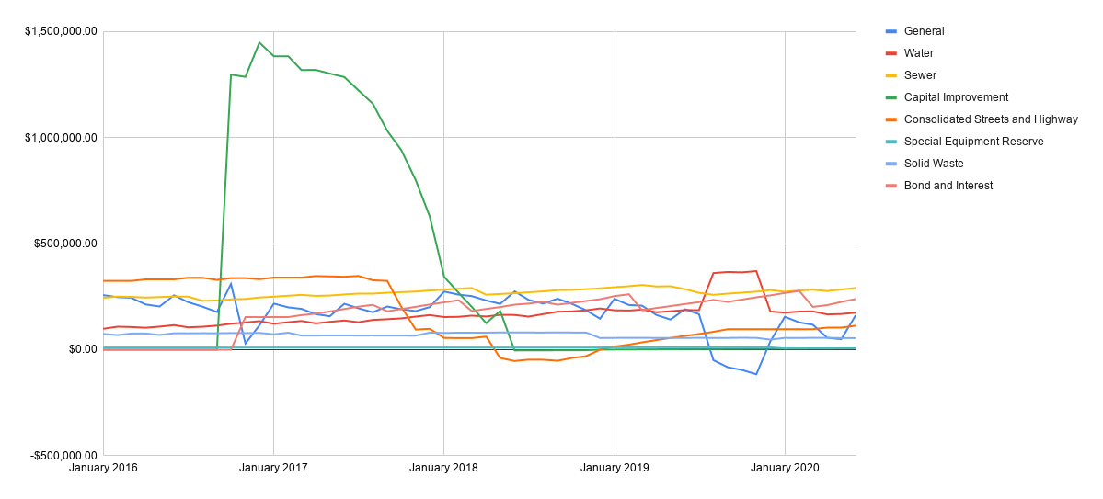

Published Budget Status:
Fund (May) | Current | Bugeted | Remaining | Percent Remaining
General | $325,763.81 | $656,342.00 | $330,578.19 | 50.37%
Consolidated Street and Hwy | $2,241.38 | $113,000.00 | $110,758.62 | 98%
Water | $108,303.51 | $255,205.00 | $146,901.49 | 57.56%
Sewer | $59,914.00 | $160,562.00 | $100,648.00 | 62.68%
Solid Waste | $43,698.88 | $99,273.00 | $55,574.12 | 55.98%
Total | $539,921.58 | 1,284,382 | $744,460.42 | 57.96%
Outstanding Indebtedness | Current | Budgeted | Remaining
G.O. Bonds | $87,148.75 | $1,535,000.00
Other | $0.00 | $47,240.00
Total | $87,148.75 | $1,582,240.00

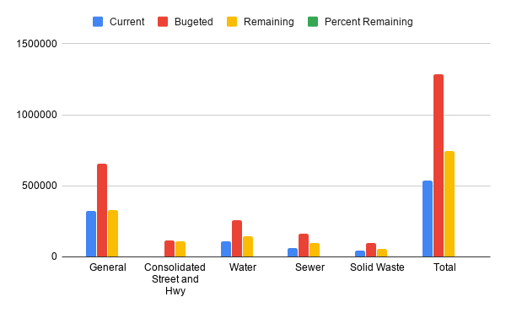

Published Budget w/ Cuts (-15%):
Fund (May) | Current | Bugeted | Remaining | Percent Remaining
General | $325,763.81 | $557,890.70 | $232,126.89 | 41.61%
Consolidated Street and Hwy | $2,241.38 | $96,050.00 | $93,808.62 | 98%
Water | $108,303.51 | $191,424.25 | $83,120.74 | 43.42%
Sewer | $59,914.00 | $136,477.70 | $76,563.70 | 56.10%
Solid Waste | $43,698.88 | $99,273.00 | $55,574.12 | 55.98%
Total | $539,921.58 | 1,081,116 | $541,194.07 | 50.06%
Outstanding Indebtedness | Current | Budgeted | Remaining
G.O. Bonds | $87,148.75 | $1,535,000.00
Other | $0.00 | $47,240.00
Total | $87,148.75 | 1,582,240

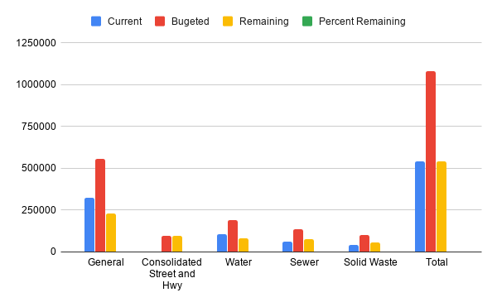

Income/Expenses (All funds):

Fund | 1/2020 | 2/2020 | 3/2020 | 4/2020 | 5/2020 | 6/2020 | 7/2020 | 8/2020 | 9/2020 | 10/2020 | 11/2020 | 12/2020 | Total
General
Income | $179,822.75 | $22,686.49 | $30,830.98 | $19,149.75 | $41,437.20 | $154,979.06 |  |  |  |  |  |  | $448,906.23
Expenses | $64,017.97 | $48,922.41 | $41,787.22 | $80,780.33 | $48,061.37 | $42,016.85 |  |  |  |  |  |  | $325,586.15
Result | $115,804.78 | -$26,235.92 | -$10,956.24 | -$61,630.58 | -$6,624.17 | $112,962.21 |  |  |  |  |  |  | $123,320.08
Consolidated Street and Hwy
Income | $0.00 | $0.00 | $0.00 | $0.00 | $0.00 | $11,474.93 |  |  |  |  |  |  | $11,474.93
Expenses | $0.00 | $0.00 | $0.00 | $0.00 | $0.00 | $2,241.38 |  |  |  |  |  |  | $2,241.38
Result | $0.00 | $0.00 | $0.00 | $0.00 | $0.00 | $9,233.55 |  |  |  |  |  |  | $9,233.55
Water
Income | $16,664.85 | $18,124.98 | $16,310.51 | $16,906.78 | $17,593.11 | $17,063.14 |  |  |  |  |  |  | $102,663.37
Expenses | $22,169.23 | $13,056.19 | $15,303.07 | $31,279.07 | $17,129.43 | $9,366.52 |  |  |  |  |  |  | $108,303.51
Result | -$5,504.38 | $5,068.79 | $1,007.44 | -$14,372.29 | $463.68 | $7,696.62 |  |  |  |  |  |  | -$5,640.14
Sewer
Income | $10,760.16 | $12,404.09 | $11,157.13 | $11,953.58 | $11,635.36 | $11,718.45 |  |  |  |  |  |  | $69,628.77
Expenses | $18,604.29 | $6,622.05 | $7,482.90 | $18,177.62 | $4,463.12 | $4,564.02 |  |  |  |  |  |  | $59,914.00
Result | -$7,844.13 | $5,782.04 | $3,674.23 | -$6,224.04 | $7,172.24 | $7,154.43 |  |  |  |  |  |  | $9,714.77
Solid Waste
Income | $8,161.51 | $7,762.36 | $8,297.09 | $8,641.94 | $8,223.20 | $9,655.50 |  |  |  |  |  |  | $50,741.60
Expenses | $0.00 | $7,920.34 | $8,040.34 | $8,331.86 | $9,350.19 | $10,056.15 |  |  |  |  |  |  | $43,698.88
Result | $8,161.51 | -$157.98 | $256.75 | $310.08 | -$1,126.99 | -$400.65 |  |  |  |  |  |  | $7,042.72
Outstanding indebtedness
G.O. Bonds
Income | $11,320.06 | $9,800.67 | $10,817.84 | $8,158.46 | $16,141.92 | $13,633.30 |  |  |  |  |  |  | $69,872.25
Expenses | $0.00 | $0.00 | $86,148.75 | $0.00 | $1,000.00 | $0.00 |  |  |  |  |  |  | $87,148.75
Result | $11,320.06 | $9,800.67 | -$75,330.91 | $8,158.46 | $15,141.92 | $13,633.30 |  |  |  |  |  |  | -$17,276.50

Sales Tax:

TOTAL Sales TAX DEPOSIT | 2015 | 2016 | % Change | 2017 | % Change | 2018 | % Change | 2019 | % Change | 2020 | % Change | Average % change
January | $13,401.81 | $12,895.69 | -3.92% | $14,398.88 | 10.44% | $24,672.44 | 41.64% | $34,318.72 | 28.11% | $26,969.47 | -27.25% | 9.80%
February | $14,923.40 | $14,081.07 | -5.98% | $15,627.19 | 9.89% | $24,815.10 | 37.03% | $22,718.87 | -9.23% | $24,985.22 | 9.07%
March | $12,916.24 | $14,043.23 | 8.03% | $22,668.30 | 38.05% | $25,727.55 | 11.89% | $25,966.89 | 0.92% | $27,295.41 | 4.87% | 12.75%
April | $12,199.70 | $12,437.80 | 1.91% | $18,290.85 | 32.00% | $24,205.51 | 24.44% | $25,974.43 | 6.81% | $20,984.25 | -23.78%
May | $14,225.73 | $15,024.13 | 5.31% | $24,201.31 | 37.92% | $22,103.72 | -9.49% | $25,050.72 | 11.76% | $37,111.65 | 32.50%
June | $12,349.56 | $14,580.10 | 2.43% | $28,487.61 | 48.82% | $27,657.25 | -3.00% | $23,738.47 | -16.51% | $32,889.37 | 27.82% | 11.91%
July | $16,846.88 | $14,428.77 |  | $26,360.70 | 45.26% | $23,039.16 | -14.42% | $22,616.87 | -1.87%
August | $14,705.54 | $13,941.85 |  | $21,592.98 | 35.43% | $21,313.05 | -1.31% | $24,090.31 | 11.53%
September | $13,716.30 | $14,933.70 | 8.15% | $26,767.40 | 44.21% | $23,401.20 | -14.38% | $31,216.55 | 25.04% |  |  | 12.60%
October | $13,408.89 | $14,758.20 | 9.14% | $26,239.30 | 43.76% | $21,482.90 | -22.14% | $24,904.69 | 13.74% |  |  | 11.12%
November | $14,511.03 | $14,532.65 |  | $26,992.85 | 46.16% | $22,209.64 | -21.54% | $26,383.73 | 15.82%
December | $14,994.79 | $16,126.28 |  | $26,529.08 | 39.21% | $21,206.04 | -25.10% | $22,557.28 | 5.99%
Total | $168,199.87 | $171,783.47 | 2.09% | $278,156.45 | 38.24% | $281,833.56 | 1.30% | $309,537.53 | 8.95% | $170,235.37 | -81.83% | -6.25%
Average | $14,016.66 | $14,315.29 |  | $23,179.70 | 35.93% | $23,486.13 | 0.30% | $25,794.79 | 7.68% | $28,372.56 | 3.87%

Property Tax:

TOTAL PROPERTY TAX DEPOSIT | 2015 | 2016 | % Change | 2017 | % Change | 2018 | % Change | 2019 | % Change | 2020 | % Change | Average % change
January | $103,777.66 | $108,379.23 | 4.25% | $114,902.10 | 5.68% | $116,959.00 | 1.76% | $117,494.68 | 0.46% | $147,221.34 | 20.19% | 6.47%
February
March | $13,052.23 | $12,066.47 | -8.17% | $10,603.23 | -13.80% | $8,143.93 | -30.20% | $13,722.86 | 40.65% | $8,830.27 | -55.41% | -13.38%
April
May | $74,603.60
June |  | $80,198.62 | 6.98% | $76,373.70 | -5.01% | $75,082.61 | -1.72% | $90,971.45 | 17.47% | $100,868.66 | 9.81% | 5.51%
July
August
September | $25,301.16 | $21,446.73 | -17.97% | $31,571.04 | 32.07% | $26,706.89 | -18.21% | $20,181.01 | -32.34% |  |  | -7.29%
October | $6,052.41 | $2,778.11 | -117.86% | $2,470.98 | -12.43% | $2,939.34 | 15.93% | $4,519.58 | 34.96% |  |  | -19.85%
November
December
Total | $222,787.06 | $224,869.16 | 0.93% | $235,921.05 | 4.68% | $229,831.77 | -2.65% | $246,889.58 | 6.91% | $256,920.27 | 3.90% | 2.75%
Average | $44,557.41 | $44,973.83 |  | $47,184.21 |  | $45,966.35 |  | $49,377.92 |  | $85,640.09

